Rising Waters: A Machine Learning Approach to Flood Prediction

Project Description:
“Rising Waters: A Machine Learning Approach to Flood Prediction” is a data-driven system designed to predict the likelihood of floods using historical environmental and meteorological data. The project leverages machine learning techniques to analyze patterns in factors such as rainfall, temperature, humidity, and water levels, enabling early identification of flood risks.
The system follows a structured workflow that includes dataset collection, preprocessing, feature selection, normalization, model training, and evaluation. By using supervised learning algorithms, the model learns relationships between environmental conditions and past flood occurrences to make accurate predictions on new data.
This project aims to support disaster management authorities and environmental agencies by providing an intelligent decision-support tool for early warning and risk assessment. With timely predictions, preventive measures can be taken to reduce damage, protect infrastructure, and save human lives. The solution also demonstrates how machine learning can be applied to real-world environmental challenges and can be further expanded into a real-time flood monitoring and alert system.

Technical Architecture:
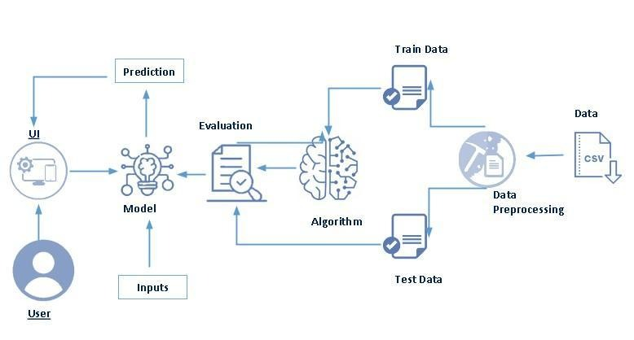

Pre requisites:
To complete this project, you must required following software’s, concepts and packages
- Anaconda navigator and pycharm:
  - Refer the link below to download anaconda navigator
  - Link : https://youtu.be/1ra4zH2G4o0
- Python packages:
- Open anaconda prompt as administrator
- Type “pip install numpy” and click enter.
- Type “pip install pandas” and click enter.
- Type “pip install scikit-learn” and click enter.
- Type ”pip install matplotlib” and click enter.
- Type ”pip install seaborn” and click enter.
- Type “pip install Flask” and click enter.

Prior Knowledge:
You must have prior knowledge of following topics to complete this project.
- ML Concepts
  - Supervised learning: https://www.javatpoint.com/supervised-machine-learning
  - Unsupervised learning: https://www.javatpoint.com/unsupervised-machine-learning
  - Regression and classification
- Decision tree: https://www.javatpoint.com/machine-learning-decision-tree-classification-algorithm
- Random forest: https://www.javatpoint.com/machine-learning-random-forest-algorithm
- KNN: https://www.javatpoint.com/k-nearest-neighbor-algorithm-for-machine-learning
- Xgboost: https://www.analyticsvidhya.com/blog/2018/09/an-end-to-end-guide-to-understand-the-math-behind-xgboost/
- Evaluation metrics: https://www.analyticsvidhya.com/blog/2019/08/11-important-model-evaluation-error-metrics/
- Flask Basics : https://www.youtube.com/watch?v=lj4I_CvBnt0

Project Objectives:
The main objectives of the project “Rising Waters: A Machine Learning Approach to Flood Prediction” are:
- To develop an intelligent system that predicts flood occurrences using machine learning techniques.
- To collect and utilize historical environmental and meteorological data for analysis.
- To preprocess the dataset by handling missing values, selecting relevant features, and converting data into a usable format.
- To apply feature scaling and normalization techniques to improve model performance.
- To split the dataset into training and testing sets for accurate model evaluation.
- To train a supervised machine learning model capable of identifying patterns related to flood events.
- To evaluate the model using performance metrics such as accuracy, precision, recall, and F1-score.
- To create a reliable prediction system that supports early warning and disaster management planning.
- To reduce human dependency on manual flood prediction methods through automation.
- To provide a scalable foundation that can be extended with real-time data, IoT sensors, and web/mobile alert systems in the future.

Project Flow:
- User interacts with the UI to enter the input.
- Entered input is analyzed by the model which is integrated.
- Once model analyses the input the prediction is showcased on the UI

To accomplish this, we have to complete all the activities listed below,
- Data collection
  - Collect the dataset or create the dataset
- Visualizing and analyzing data
- Import the Libraries.
- Univariate analysis
- Multivariate analysis
- Descriptive analysis
- Data pre-processing
  - Checking for null values
  - Handling outlier
  - Handling categorical data
  - Splitting the dependent and independent variables
  - Splitting data into train and test
  - Feature scaling
- Model building
  - Import the model building libraries
  - Initializing the model
  - Training and testing the model
  - Evaluating performance of model
  - Save the model
- Application Building
  - Create an HTML file
  - Build python code

Project Structure:
Create the Project folder which contains files as shown below
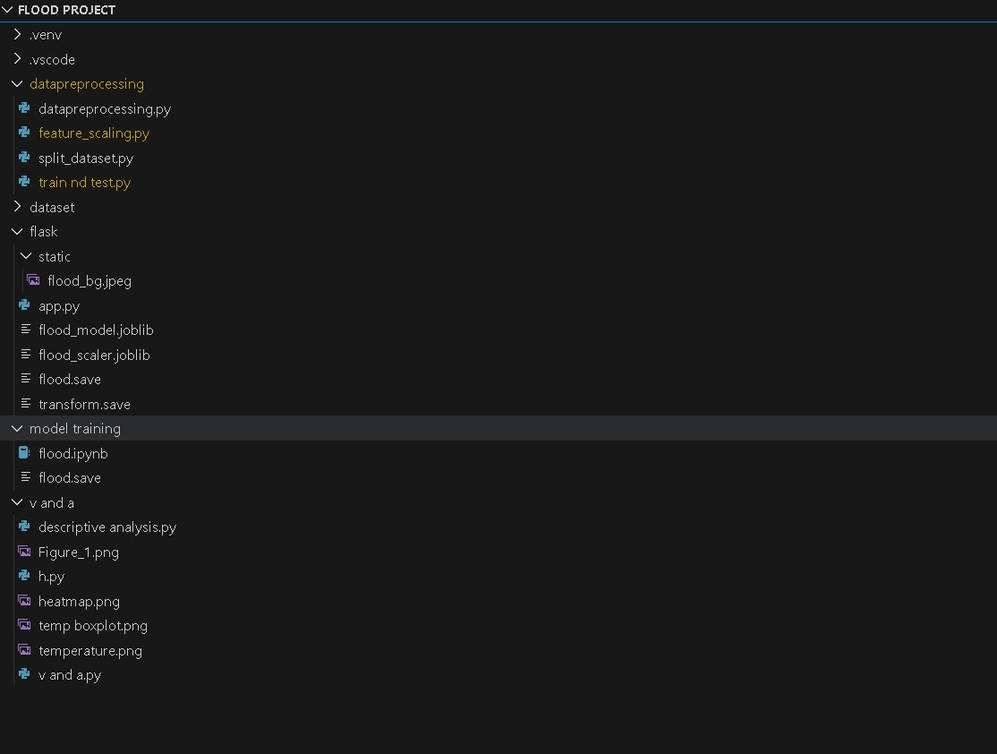
- We are building a flask application which needs HTML pages stored in the templates folder and a python script app.py for scripting.
- ‘flood.save’ is our saved model. Further we will use this model for flask integration.
- Training folder contains model training files

Milestone 1: Data Collection
ML depends heavily on data, It is most crucial aspect that makes algorithm training possible. So this section allows you to download the required dataset.
Activity 1: Download the dataset
There are many popular open sources for collecting the data. Eg: kaggle.com, UCI repository, etc.
In this project we have used flood_dataset.xlsx data. This data is downloaded from kaggle.com. Please refer to the link given below to download the dataset.
Link: https://www.kaggle.com/datasets/arbethi/rainfall-dataset

Milestone 2: Visualizing and analysing the data
As the dataset is downloaded. Let us read and understand the data properly with the help of some visualization techniques and some analysing techniques.
Note: There is n number of techniques for understanding the data. But here we have used some of it. In an additional way, you can use multiple techniques.
Activity 1: Importing the libraries
In the project “Rising Waters: A Machine Learning Approach to Flood Prediction,” importing libraries is the first step in model development. These libraries provide the necessary tools for data handling, preprocessing, model building, and saving the trained model.
The following Python libraries are used:
- Pandas – Used for loading, reading, and manipulating the dataset.
- NumPy – Used for numerical computations and array operations.
- Scikit-learn – Provides tools for:
  - Data splitting
  - Feature scaling
  - Model training and evaluation
- StandardScaler – Used for normalizing the dataset to improve model performance.
- Train_test_split – Used to divide the dataset into training and testing data.
- Joblib – Used to save the trained machine learning model for future use.
These libraries help in building an efficient and scalable machine learning pipeline for predicting flood occurrences.
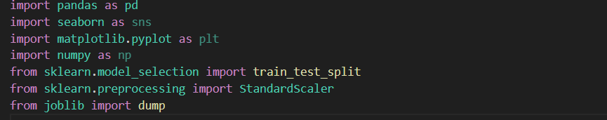
Activity 2: Read the Dataset
In this activity, the flood dataset is loaded into the system for analysis and model building. The dataset is stored in Excel format and contains environmental and flood-related parameters required for prediction.
Using Python, the dataset is read with the help of the Pandas library and converted into a data frame for further processing.
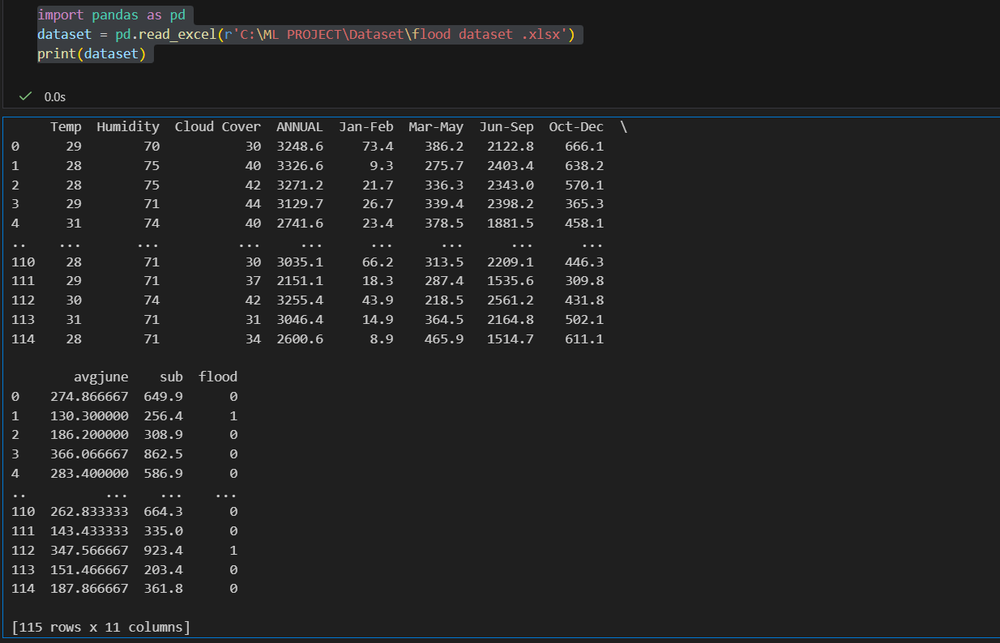

Activity 3: Univariate analysis
Univariate analysis is the process of analyzing a single variable in the dataset to understand its distribution, pattern, and behavior. In this project, it is used to study individual environmental factors such as temperature, rainfall, and humidity before building the machine learning model.
This activity is performed using visualization techniques like histograms and boxplots. A histogram helps in understanding the frequency distribution of the variable, while a boxplot helps in identifying spread and outliers.
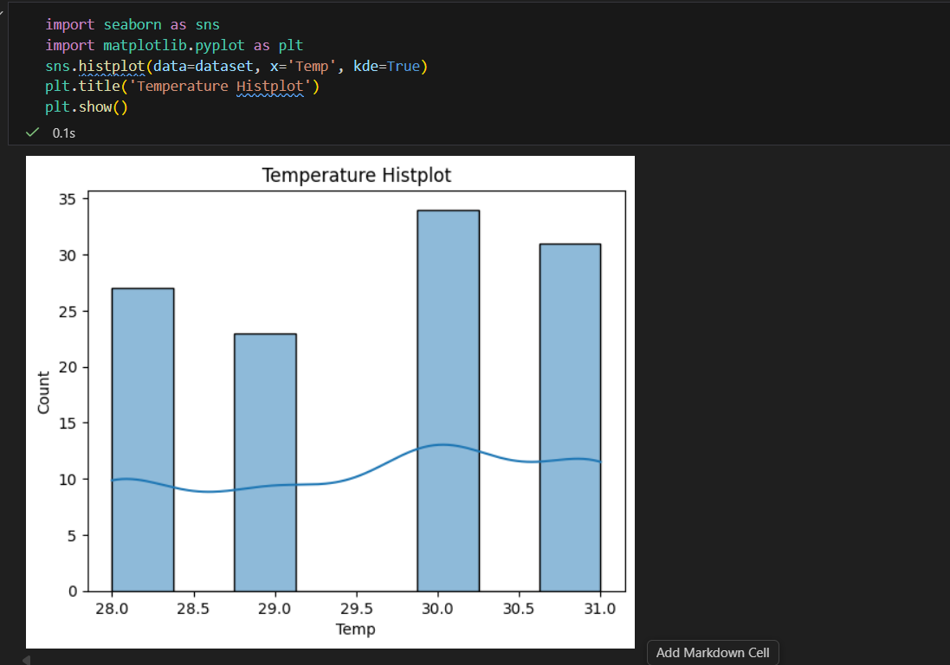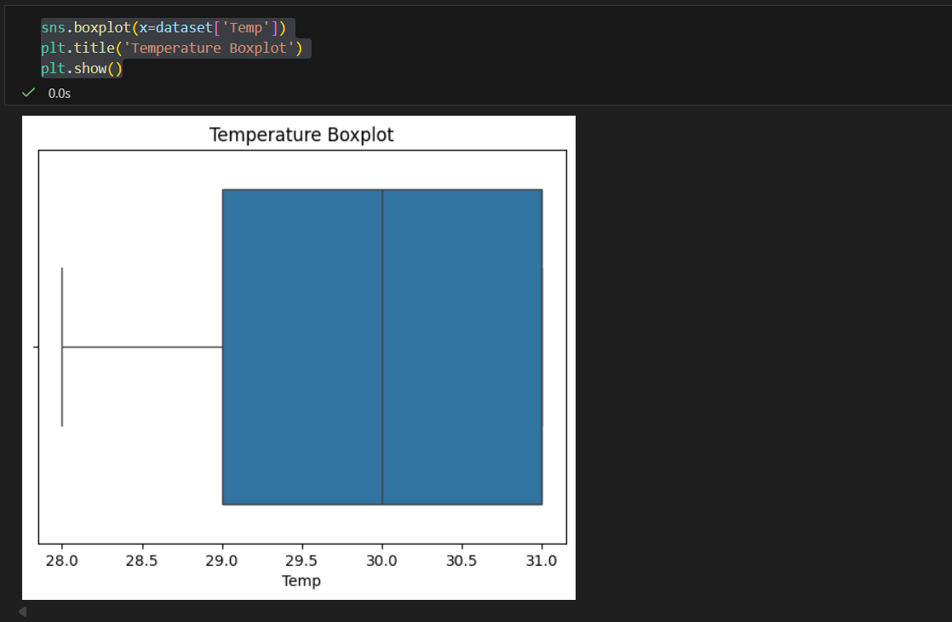

Activity 4: Multivariate analysis
Multivariate analysis is carried out to examine the relationships among multiple variables in the dataset simultaneously. In this project, it helps in understanding how environmental factors such as temperature, humidity, rainfall patterns, cloud cover, and seasonal values collectively influence flood occurrence.
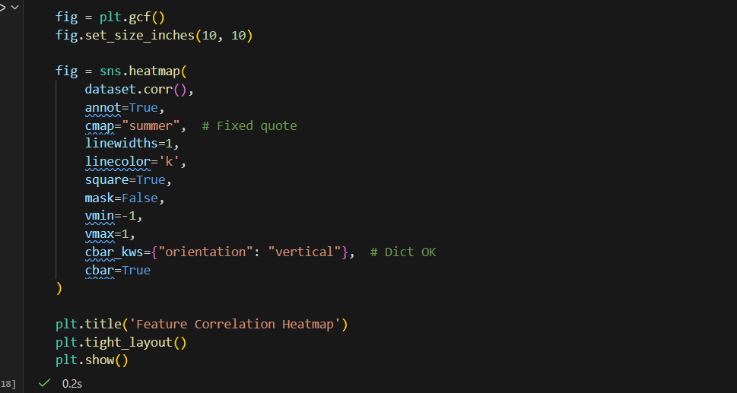
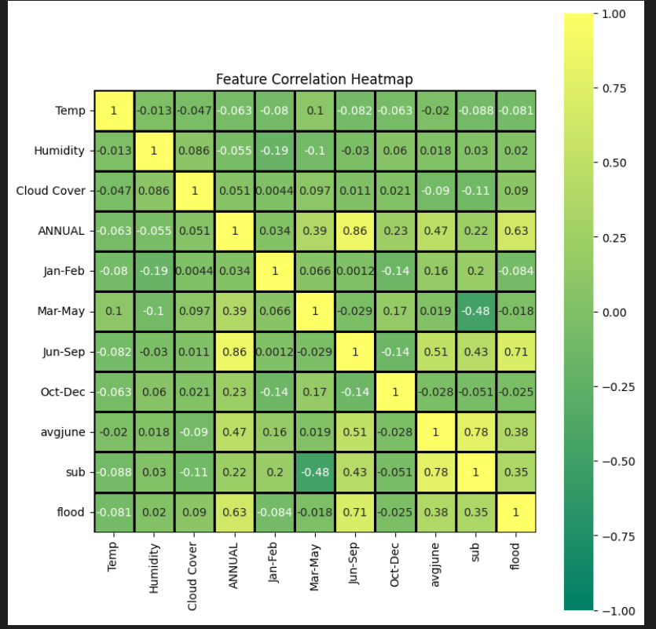
A correlation heatmap is used to visualize the strength and direction of relationships between all features. It shows how each variable is related to others and to the flood output variable.
Activity 5: Descriptive analysis
Descriptive analysis is performed to summarize and understand the main characteristics of the dataset using statistical measures. In this project, it helps in examining environmental variables such as temperature, humidity, rainfall, and other flood-related parameters.
This activity includes calculating statistical values such as mean, median, mode, minimum, maximum, and standard deviation for each feature in the dataset.
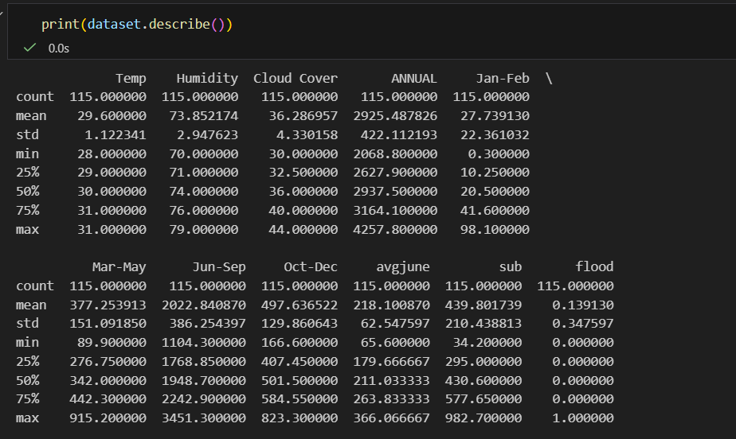
Descriptive analysis provides a clear overview of the data and forms the foundation for further steps like visualization, preprocessing, and machine learning model development.

Milestone 3: Data Pre-processing
As we have understood how the data is lets pre-process the collected data.
The download data set is not suitable for training the machine learning model as it might have so much of randomness so we need to clean the dataset properly in order to fetch good results. This activity includes the following steps.
- Handling missing values
- Handling categorical data
- Handling outliers
- Splitting the dependent and independent variables
- Splitting dataset into training and test set
- Feature scaling

Note: These are the general steps of pre-processing the data before using it for machine learning. Depending on the condition of your dataset, you may or may not have to go through all these steps.

Activity 1: Checking for null values
- Let’s find the data type, df.info() function is used.
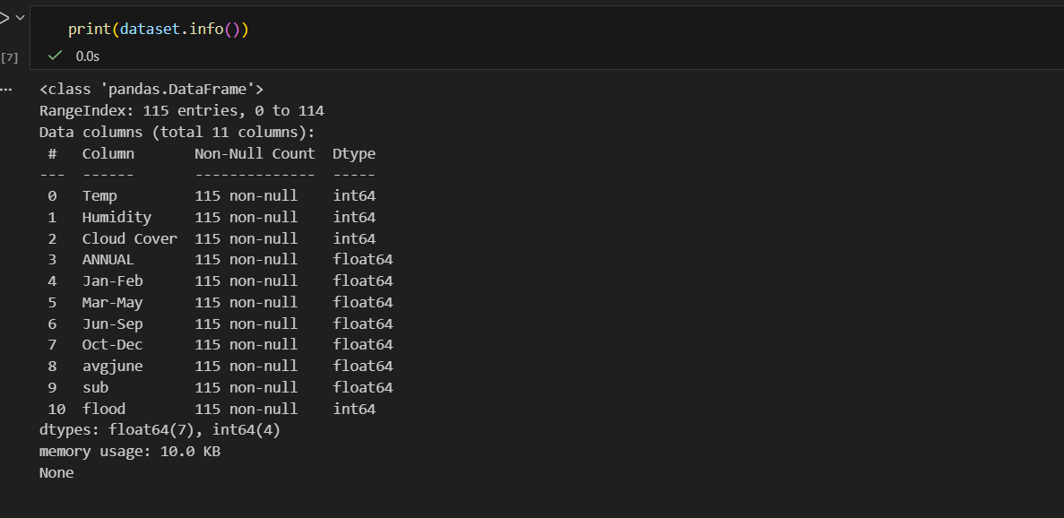

- For checking the null values, df.isnull() function is used. To sum those null values we use .sum() function to it. From the below image we found that there are no null values present in our dataset. So we can skip handling of missing values step.

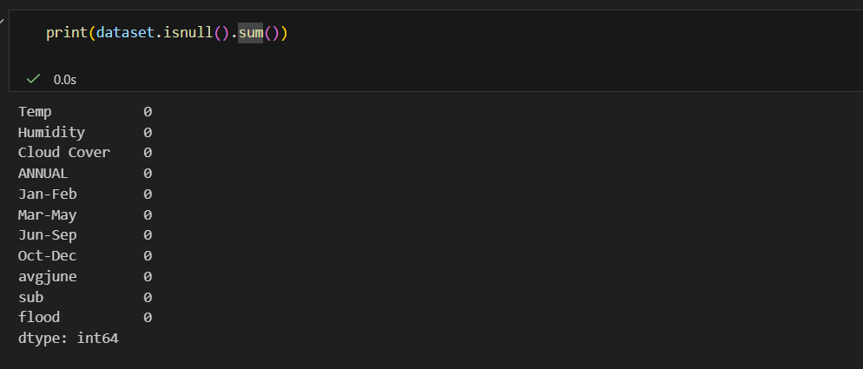

Activity 2: Handling Categorical Values
In our dataset, there is no categorical data type, so we can skip this step.
Activity 3: Handling Outliers:
With the help of boxplot, outliers are visualized (refer activity 3 univariate analysis). And here we are going to find upper bound and lower bound of Na_to_K feature with some mathematical formula.
- To find the upper bound we have to multiply IQR (Interquartile range) with 1.5 and add it with 3rd quantile. To find lower bound instead of adding, subtract it with 1st quantile. Take image attached below as your reference.
- If outliers are removed, we lose more data. It will impact model performance.
- Here removing outliers is impossible. So, the capping technique is used on outliers.
- Capping: Replacing the outliers with upper bound values.

Note: In our Dataset Outliers were detected using the Interquartile Range (IQR) method to identify extreme values in the dataset. The analysis showed that most outliers were present in rainfall-related features. Since extreme rainfall values are directly associated with flood events, they represent meaningful real-world conditions. No physically impossible or erroneous values were found in the dataset. Therefore, all detected outliers were retained to preserve important flood-related patterns and improve model performance.
Activity 4: Scaling the Data
Standard Scaler: Sklearn its main scaler, the StandardScaler, uses a strict definition of standardization to standardize data. It purely centers the data by using the following formula, where u is the mean and s is the standard deviation.
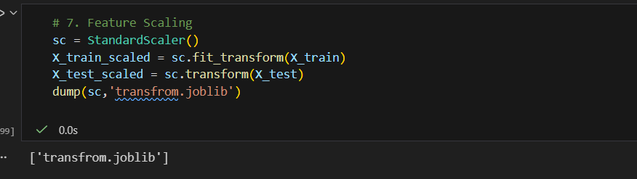
We will perform scaling only on the input values
Once the dataset is scaled, it will be converted into array and we need to convert it back to dataframe.
Activity : Splitting data into train and test
Now let’s split the Dataset into train and test sets
Changes: first split the dataset into x and y and then split the data set
Here x and y variables are created. On x variable, df is passed with dropping the target variable. And on y target variable is passed. For splitting training and testing data we are using train_test_split() function from sklearn. As parameters, we are passing x, y, test_size, random_state.
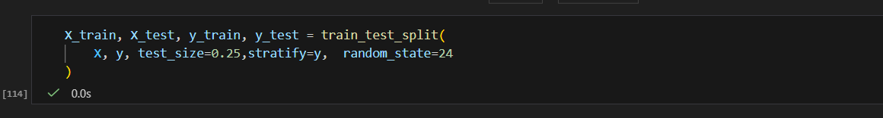

Milestone 4: Model Building
Now our data is cleaned and it’s time to build the model. We can train our data on different algorithms. for this project we are applying four classification algorithms. The best model is saved based on its performance.
Activity 1: Decision tree model
A function named decisionTree is created and train and test data are passed as the parameters. Inside the function, DecisionTreeClassifier algorithm is initialized and training data is passed to the model with .fit() function. Test data is predicted with .predict() function and saved in new variable. For evaluating the model, confusion matrix and classification report is done.
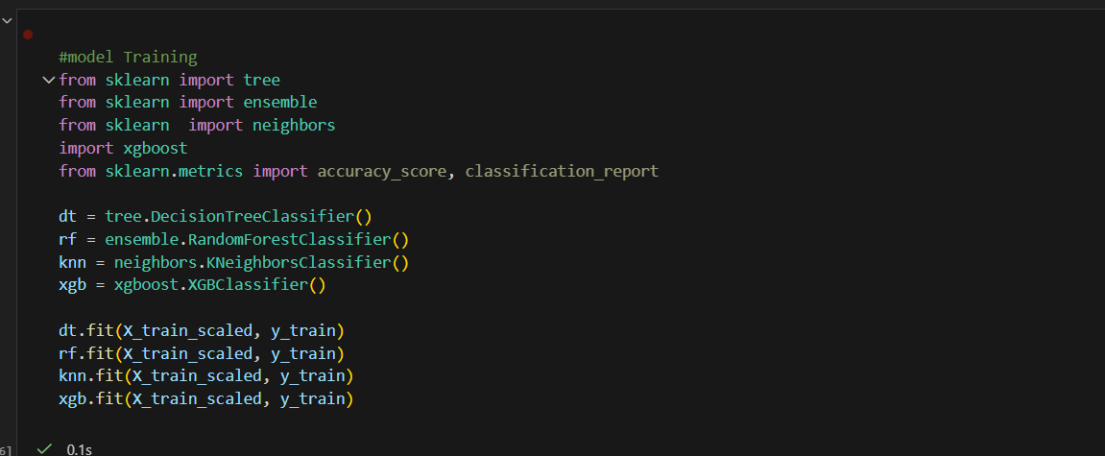
Activity 2: Random forest model
A function named randomForest is created and train and test data are passed as the parameters. Inside the function, RandomForestClassifier algorithm is initialized and training data is passed to the model with .fit() function. Test data is predicted with .predict() function and saved in new variable. For evaluating the model, confusion matrix and classification report is done.
Activity 3: KNN model
A function named KNN is created and train and test data are passed as the parameters. Inside the function, KNeighborsClassifier algorithm is initialized and training data is passed to the model with .fit() function. Test data is predicted with .predict() function and saved in new variable. For evaluating the model, confusion matrix and classification report is done.
Activity 4: Xgboost model
A function named xgboost is created and train and test data are passed as the parameters. Inside the function, GradientBoostingClassifier algorithm is initialized and training data is passed to the model with .fit() function. Test data is predicted with .predict() function and saved in new variable. For evaluating the model, confusion matrix and classification report is done.
Now let’s see the performance of all the models and save the best model

Activity 5: Compare the model
After training, all models were evaluated using the test dataset. The primary evaluation metric used was Accuracy Score.
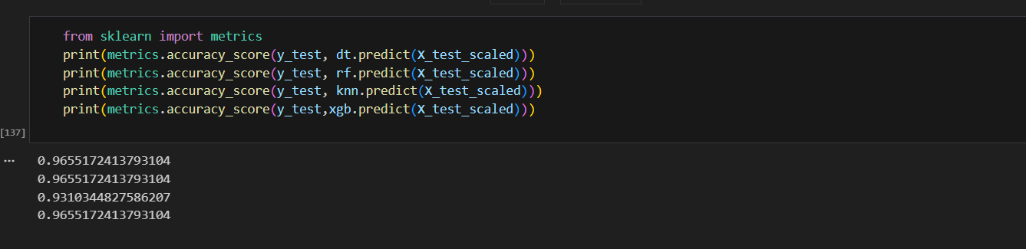
From the comparison:
- KNN showed comparatively lower accuracy.
- Decision Tree, Random Forest, and XGBoost showed similar high performance.
- XGBoost was selected for final implementation due to its boosting capability and better generalization strength.
Activity 6: Evaluating performance of the model and saving the model
Based on the performance comparison, XGBoost Classifier was selected as the final model.
The final XGBoost model was evaluated using:
- Confusion Matrix
- Accuracy
- Precision
- Recall
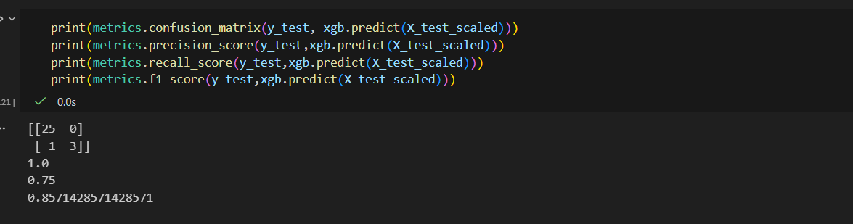
After final evaluation, the trained model was saved using Joblib.
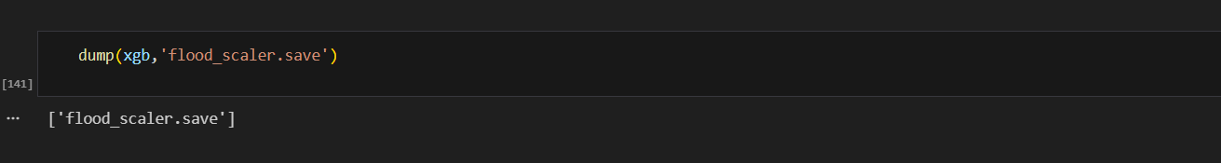

Milestone 5: Application Building
In this Milestone,we build a web application that integrates the trained Machine Learning model with a user interface. The user enters input values through the UI, and those values are passed to the saved model to generate predictions. The predicted result is then displayed back on the web page.
This section includes the following activities:
- Building HTML Pages
- Building Server-Side Script
- Running the Application
Activity1: Building Html Pages:
For this project create three HTML files namely
- home.html
- predict.html
- result.html

Let’s see how our home.html page looks like:

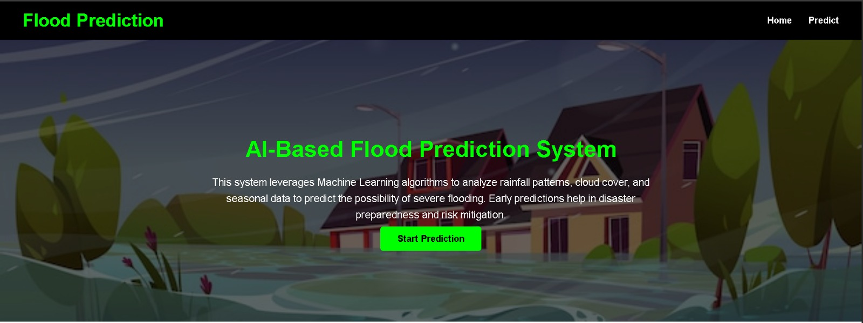
Now when you click on predict button from top right corner (or) start predict button then you will get redirected to predict.html
Lets look how our predict.html file looks like:
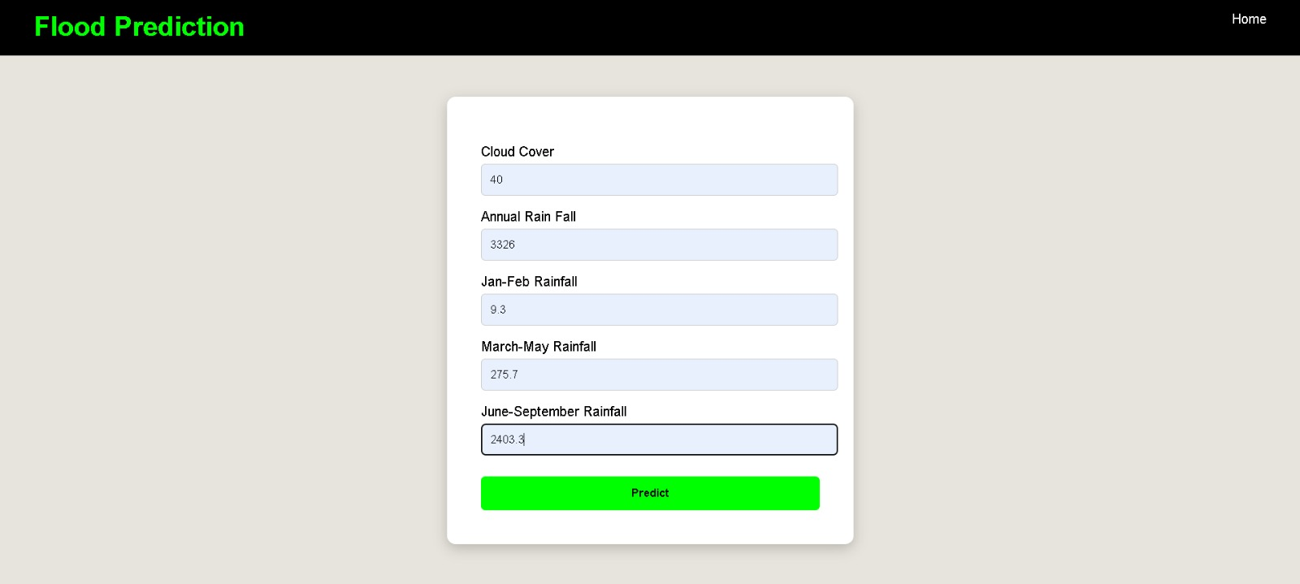
Now when you click on predict button in the form then you will get redirected to result.html
Lets look how our result.html file looks like:
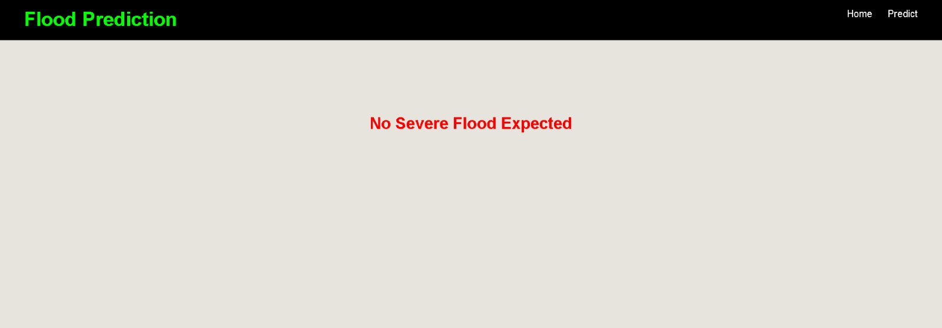
Activity 2: Build Python code:
Import the libraries
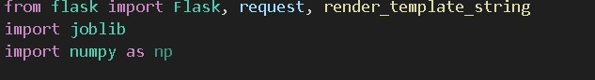
Load the saved model. Importing flask module in the project is mandatory. An object of Flask class is our WSGI application. Flask constructor takes the name of the current module (__name__) as argument.
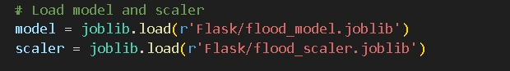

Render HTML page:
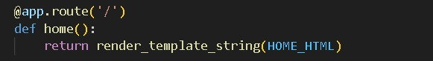
Here we will be using declared constructor to route to the HTML page which we have created earlier.

In the above example, ‘/’ URL is bound with home.html function. Hence, when the home page of the web server is opened in browser, the html page will be rendered. Whenever you enter the values from the html page the values can be retrieved using POST Method.
Retrieves the value from UI:
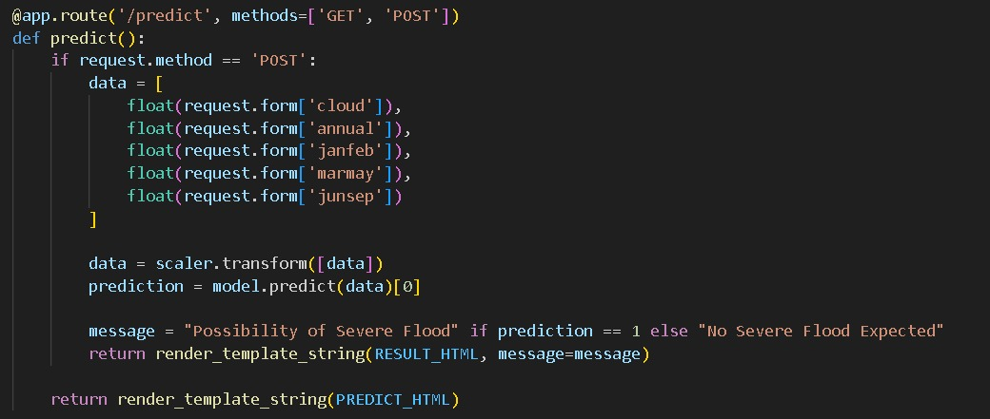

Here we are routing our app to predict() function. This function retrieves all the values from the HTML page using Post request. That is stored in an array. This array is passed to the model.predict() function. This function returns the prediction. And this prediction value will rendered to the text that we have mentioned in the submit.html page earlier.
Main Function:
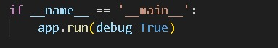
Activity 3: Run the application
- Open anaconda prompt from the start menu
- Navigate to the folder where your python script is.
- Now type “python app.py” command
- Navigate to the localhost where you can view your web page.
- Click on the predict button from top left corner, enter the inputs, click on the submit button, and see the result/prediction on the web.

